

Alarm Clock

David Hout and Derek Elam

EENG 220

11/25/2020

**Abstract**

We will be creating an alarm clock for our EENG 220 project with our FPGAs. We will be using an external 7 segment display clock to display the time. A switch will be added to set the alarm to either on or off mode. A Buzzer will be used to sound once a selected time is hit. Even when the alarm is set to off, it still keeps the time value of the alarm so it doesn’t have to be set again. We will be using two rotary encoders to set the hour and minute digit. In order to set the time for the clock, we would have a button that turns on the time set mode. Once this is enabled you can use the rotary encoders to set the time. If you want to set the time for the clock, you would need to have the alarm set to off. If you want to set the time of the alarm, then you would turn the alarm on. Once you have set the time you would press the button again to turn off the time set mode. If the team gets this part of the project done sooner than expected, then we will add a second part to the project. The second part will be a timer that will display minutes and seconds. The result of the project was that we weren’t able to implement rotary encoders and we weren’t able to add a stopwatch feature into the project. However, we were able to get the clock to work with an alarm setting and with the ability to change the time.

**First Day Tasks**

On the first day of our project, we needed to list out our assignments and start working on our project. The following were the tasks that we listed out on that day.

Checklist

* Collaboration space
* Display Code
* Clock Code
* Set the time
* Set the Alarm (Buzzer)
* Switch Between alarm and stopwatch
* Switch between set time
* Turn alarm on and off
* Setting the time (rotary encoders)

**System Block Diagram**

The following is the system block diagram that we came up with before we started on the project. This helps us determine what parts we needed for the project. From this we determined that we needed (excluding the FPGA), a buzzer, two rotary encoders, and two buttons. The two buttons are just in case we decide to go farther in the project and make a stopwatch or timer.

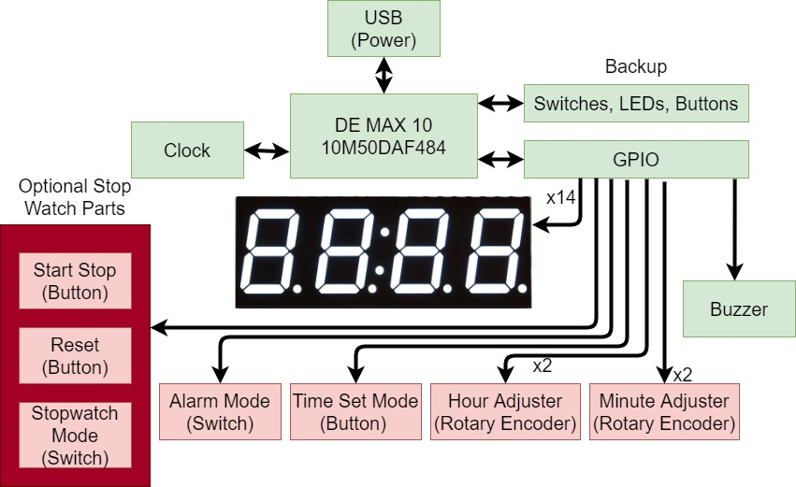

**Figure 1: System Block Diagram**

**Display**

Documentation

First attempt for the logic of the Display. Upon setting this all up I realized that all the numbers display the same thing. As well as in some of the code the 7 segment decoder was not outputting the correct high inputs to the display so I modified the code of the decoder to adjust to what was wrong. The way the 7 segment decoder worked was

**Figure 2: 7 segment logic**

Before:

ABCDEFG

4'b0000: display <= 7'b0000001;

After:

GFEDCBA

4'b0000: display <= 7'b0111111;

The reason behind the switch in the order of the numbers solely relied on where the wires were wired up from the GPIO pins to the clock display. But also you may notice that the way this clock displays is not based off of high being off, but rather low is off.

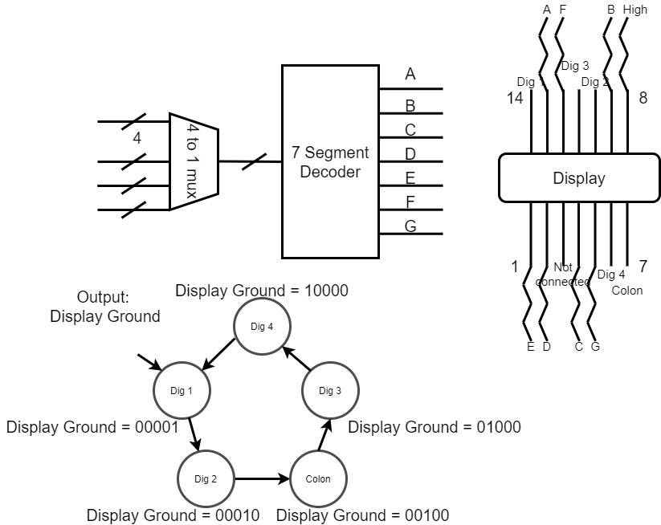

**Figure 3: Block Diagram for Display**

In Figure 3 we can see that we used a 4 bit wide 4 to 1 multiplexor to take inputs from the main clock that David made and input that into the 7 segment decoder which then went to the display. The display needs to have one grounding pin at a time rotating through which is why that finite state machine (FSM) is there at the bottom.

The way this circuit was set up did not fully work because of some issues with the display grounds and upon further investigation the way I had the display ground logic made multiple pins grounded, which would make the display only show 1 number on the 4 hex displays.

Upon further learning about high level state machines (HLSM) I realized that we could get rid of the 4 bit wide 4 to 1 multiplexor and instead make that a variable in the FSM.

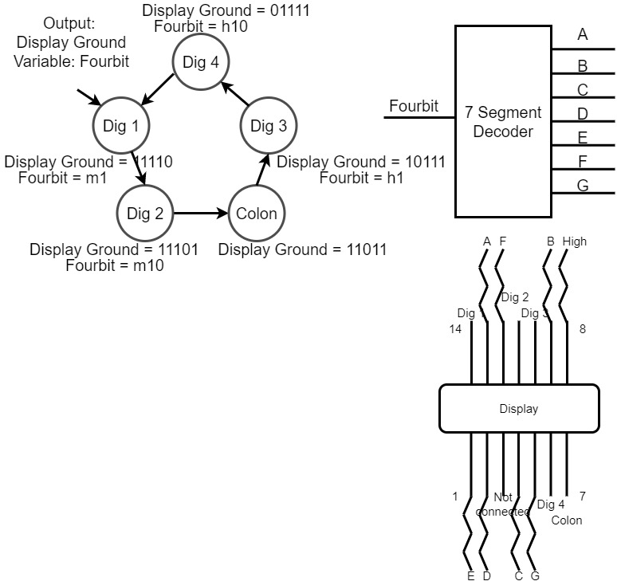

**Figure 4: HLSM block Diagram for Display**

In figure 4 we can see that there is no need to create a module for a 4 bit seven segment display now because we have piggybacked off of the FSM in order to roll through the Fourbit variable.

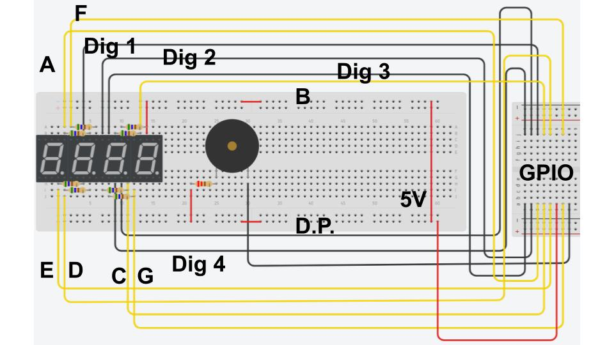

**Figure 5: Wiring Diagram for Display**

In figure 5 we have the wiring diagram for the display and this shows us what wires that we need to connect to the display from the general purpose input output pins. Each resistor is 560 ohms to cause the right amount of amperage into the display.

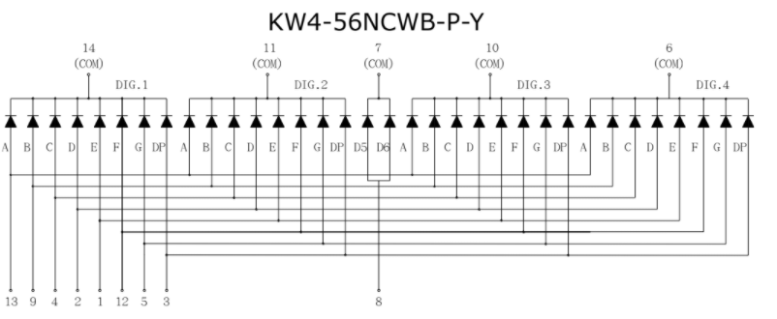

**Figure 6: Display Logic**

**Source: Adapted from [1]**

Figure 6 and Figure 5 go hand in hand. We get the display logic from figure 6 to help us set up the wiring for the display. When assigning the GPIO pin on the DE10 Lite you must use the manual to figure out which pins need to be assigned.

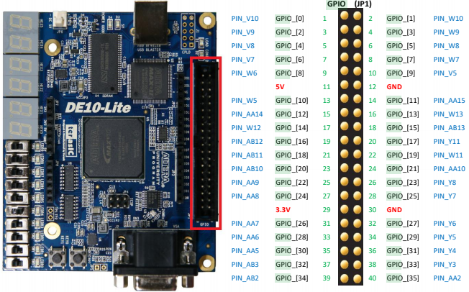

**Figure 7: GPIO Header Layout**

**Source: Adapted from [2]**

When assigning pins you must do the following:

set_location_assignment PIN_V10 -to DisplayGround[0]

set_location_assignment PIN_W8 -to inputDisplay[0]

The DisplayGround assignment is the rotating through display grounds for the Figure 6 (Com)

The inputDisplay is for all the numbers below in Figure 6. These are what is going to drive each segment to brighten up when the FPGA sets them to high voltage (5v)

**Functionality**

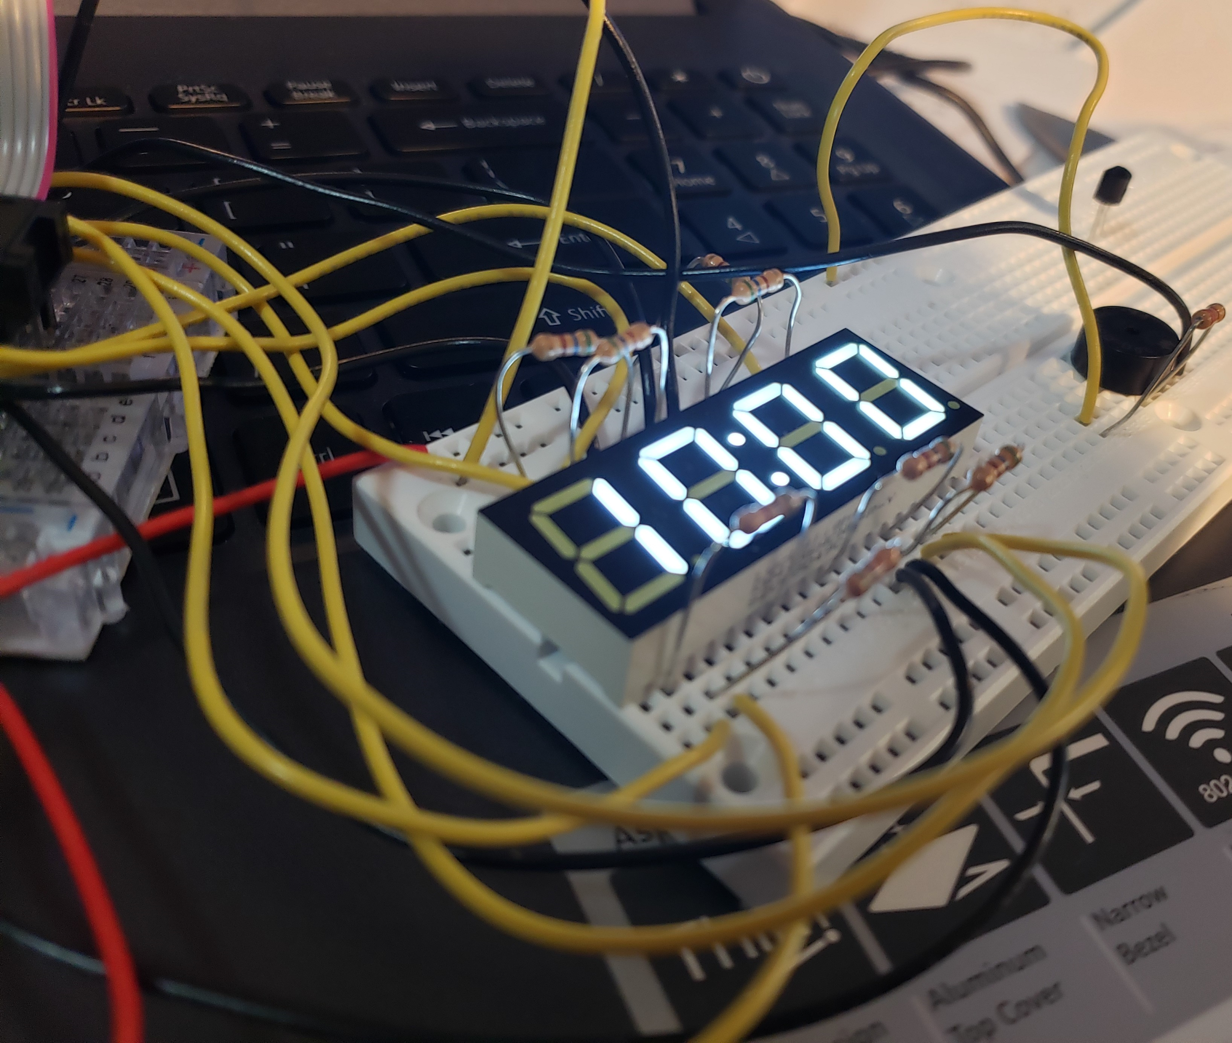

**Figure 8: 7-Segment Display Setup**

**Clock**

**Documentation**

The way that the code worked was that it got 4 inputs: 50Mhz clock, stop, switch, programmer, and a number input. The stop input stopped the clock from counting. The number input was an 8-bit input that would be used to change the minute or hour times to the number that it held. The programmer would be the input to tell the number input when to replace the minute or the hour times. The switch would “switch” from either changing the minute or hour input. The way that the module worked is that there would be a counter for the 50Mhz clock. When the counter would reach a certain number, it would add one second to the clock. The way I did this is, I took a 26 bit register and when that register hit 50 million it would reset and one second to the clock. The counter would add one at the positive edge of the 50Mhz clock.

Each part of the clock (hours, minutes, seconds) would be saved in their own 8-bit registers. The tens place of each register would be placed in the last 4 bits of the register. The ones place of each register would be placed in the first 4 bits of the register.

Next the clock needed a way to add one to the minute and the hour part. So, what I did was I added a few if statements that said when the seconds part reaches 59 seconds, it would go to the minutes and see if it equaled 59, then it would go the hour part to see if it equaled 12. If all of these cases were true then the clock would reset to seconds being zero, minutes being zero, and hour being one. If the hour was 12, then the hour would just add one and then the minutes and seconds reset to zero. If the minutes part was 59, then the minutes would add one and the seconds would reset to zero. Nothing would happen to the hours part.

The outputs of the module are each individual digit of the clock. The ones place of the minute part has an output, the tens place of the hour part has an output, etc. Each output is 4 bit. At the very end of the code, I assigned each output to the registers of the hour, minute, and second in the logic mentioned above.

The next thing that worked was the alarm. I changed clock code to have a few more inputs and one output. I added the alarm hour and the alarm minute, and an alarm enable as an input, and the buzzer as an output. After all of the logic for the clock counter I added another set of if statements.The first if statement is if the alarm is enabled. Basically if the user has turned on the alarm check to see if the alarm needs to go off. If the alarm is on and the user turns it off, the buzzer (if it’s on) will turn off. The next if statement checks to see if the alarm minute and the alarm hour is equal to the clock minute and the clock hour. If that is true then a variable will be set to one to tell the buzzer to turn on in a pattern.

The way that the pattern works is that there is a counter that counts to around a half a second. When the counter reaches half a second, the buzzer will either turn on or off. I have another single bit register variable that determines whether the buzzer is on or off. If the variable is one, the buzzer will turn on and the variable will be zero. After a half a second, the buzzer turns off and the variable will turn back to one.

**Functionality**

<https://youtu.be/p1cSdxaP8rQ>

**Rotary Encoders**

**Documentation**

Today, we met with Dr. Spicklemire (Software Engineer at University of Indianapolis) to help us with setting up git on our devices so that we could easily collaborate online without having to try to send emails of updated code and/or trying to set up google drive directories.[1]

On this day Derek continued to work on the display encoder for the 4 digit 7-segment display. I worked on figuring out how the rotary encoders worked. Based on the documentation for the rotary encoder, one output is supposed to be leading or lagging the other input based on the direction of rotation on the rotary encoders. I set up the following circuit.

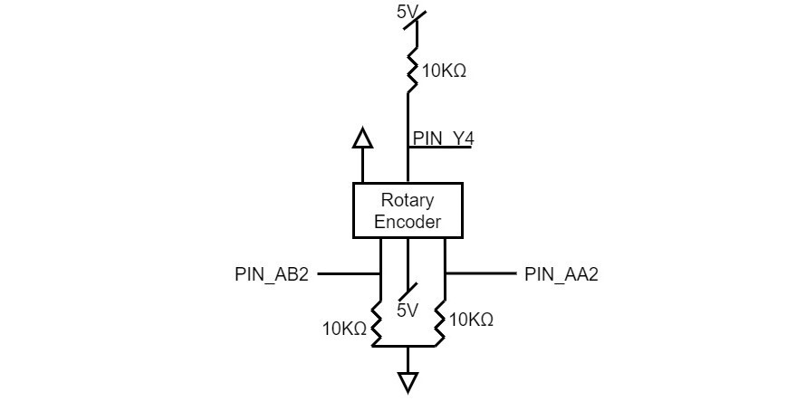

**Figure 9: First Rotary Encoder Setup**

I set up the built in oscilloscope on my Analog Discovery Studio kit to see if I could find the leading and lagging of the signals. Unfortunately I wasn’t able to find any gap in the either signals. Even after multiple attempts, over multiple time differences, and even going as far as using different rotary encoders, I still could not find any distinct leading or lagging signals. Later on, I’m going to add capacitors to the circuit in order to install a low-pass filter, in order to make clearer signals. If that doesn’t work, I may have to use the oscilloscopes in the lab, to see if it’s a sensitivity issue.

I contacted Nick Schmitt (Electronics Lab Manager at University of Indianapolis) regarding the rotary encoders and a possible solution. The solution that I came up with was the result of an observation that I made. I added a low pass filter to the outputs of the rotary encoders (suggested by Nick). I noticed that if I turned the rotary encoder clockwise, one signal will have a negative before the other, and vice versa for counter clockwise. The following shows what I found.

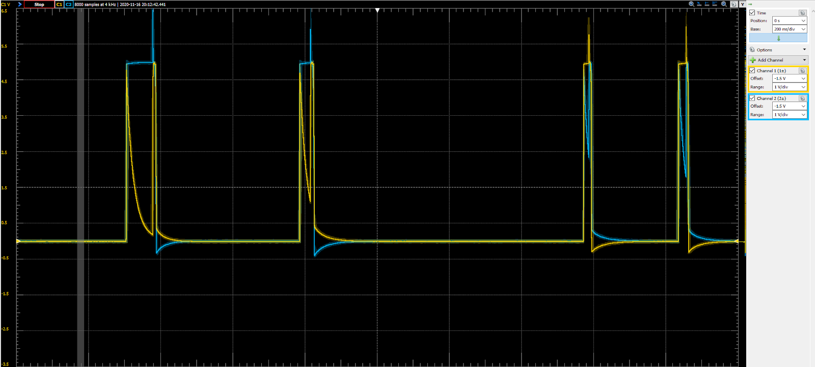

**Figure 10: Rotary Encoder Output with Capacitor**

My solution is that instead of finding the first positive edge, I could find the first negative edge. However, Nick said that he tested his own rotary encoders with an oscilloscope not the Analog Discovery Studio that I was using, and he was able to see the separate leading and lagging signals. So my next step is to use the oscilloscopes at the lab and see if I can find the leading or lagging signals. If I can, then I’m going to be using the positive edge instead of the negative edge.

I met up with Nick to find out what the problem was with the circuit I had set up. I apparently didn’t even need the capacitors to begin with. And instead of having the voltage go through the middle pin, we had the voltage go through the two outside pins. The following is a diagram of the circuit.

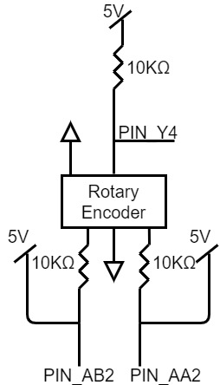

**Figure 11: Second Rotary Encoder Setup**

After setting up the circuit and setting it up on the oscilloscope I finally got a clear reading that is as expected.

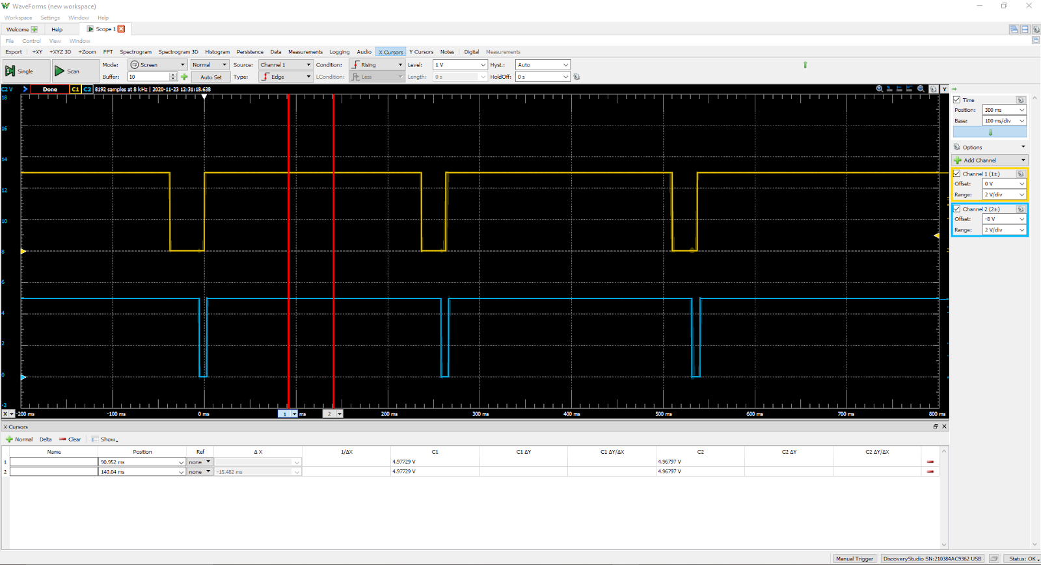

**Figure 12: Output for Second Rotary Encoder Setup**

One other thing that I did today was going over a way to add or subtract one to the hour or minute hand (depending on the knob). With the help of professor Herzog, we had come up and found a few ways of doing this. We had found a source online that has a solution, but I want to try using my own solution for this project. One solution that we had come up with is using a finite state machine. The first state would check to see if the rotary encoder is either being turned clockwise or counterclockwise. Then it goes into another state that waits for a few clock cycles to make sure that the FPGA isn’t receiving a false positive. Then it would go into a third state that would also wait a certain number of clock cycles, but it would be significantly longer. This is because we need to wait for the positive edge of the second signal so that way the state machine doesn’t just add one and then detects the second positive signal and subtracts one. After the third state has passed, the state machine lastly goes into the fourth state which adds one to the hour or minute and then goes back to the first initial state. The following picture is a diagram that was made to represent the finite state machine.

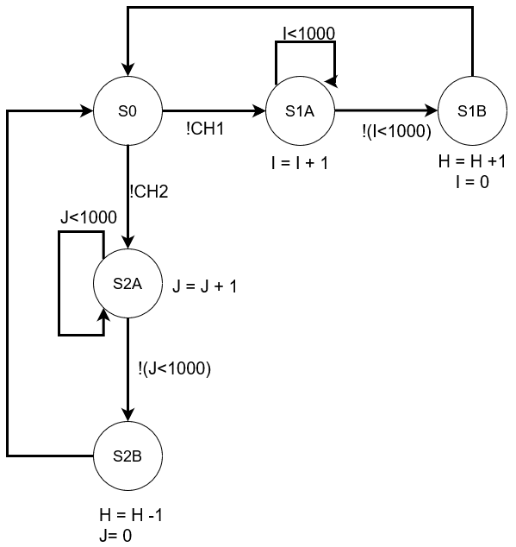

**Figure 13: First HLSM Idea**

I want to try this solution first to see if it works. If it does then it’s the one I’m going to stick with. One thing that I need to consider is what the wait times are going to be. Specifically the wait time from the rising edge of the first signal to the rising edge to the second signal. I don’t want the signal to go for too short of time, because then the FPGA will detect the rising edge of the second signal, therefore adding and subtracting from the number. I need to test and record the timing of the two positive edges while turning the rotary encoder slow, average speed, and fast.

The test that I am going to run involves the onboard oscilloscope, and a rotary encoder. The following shows the set up for this experiment. This setup will be the same set up (not the oscilloscope leads) in the final project.

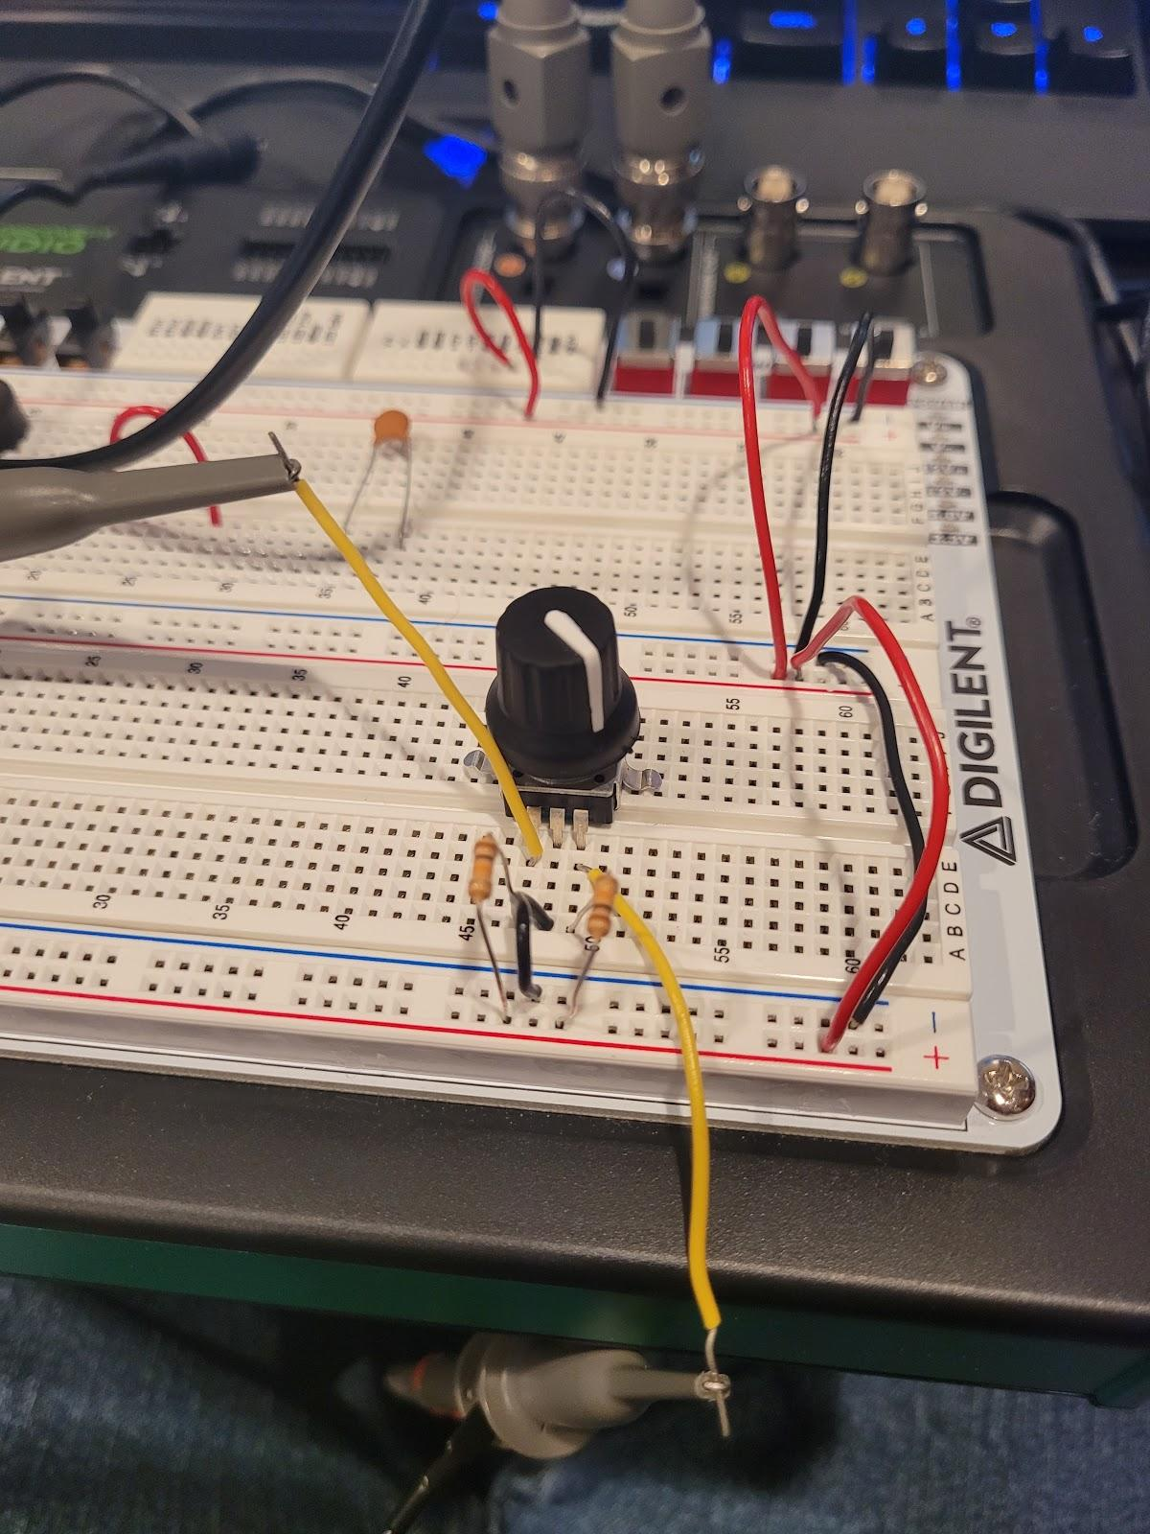

**Fig 14: Testing Set Up**

The way I ran this experiment is rotating the rotary encoder at three (relative) different speeds. I rotated slow, average, and fast speed. Then what I did was record three different turns on the rotary encoder. On each indent, I took the difference from the lowering edge of the first input and the lowering edge of the second input. The following image is an example of what the oscilloscope output is and the result that I got from each difference of the different speeds.

**SLOW:**



**Fig 15: Slow Rotary Encoder Turns**

**MEDIUM:**

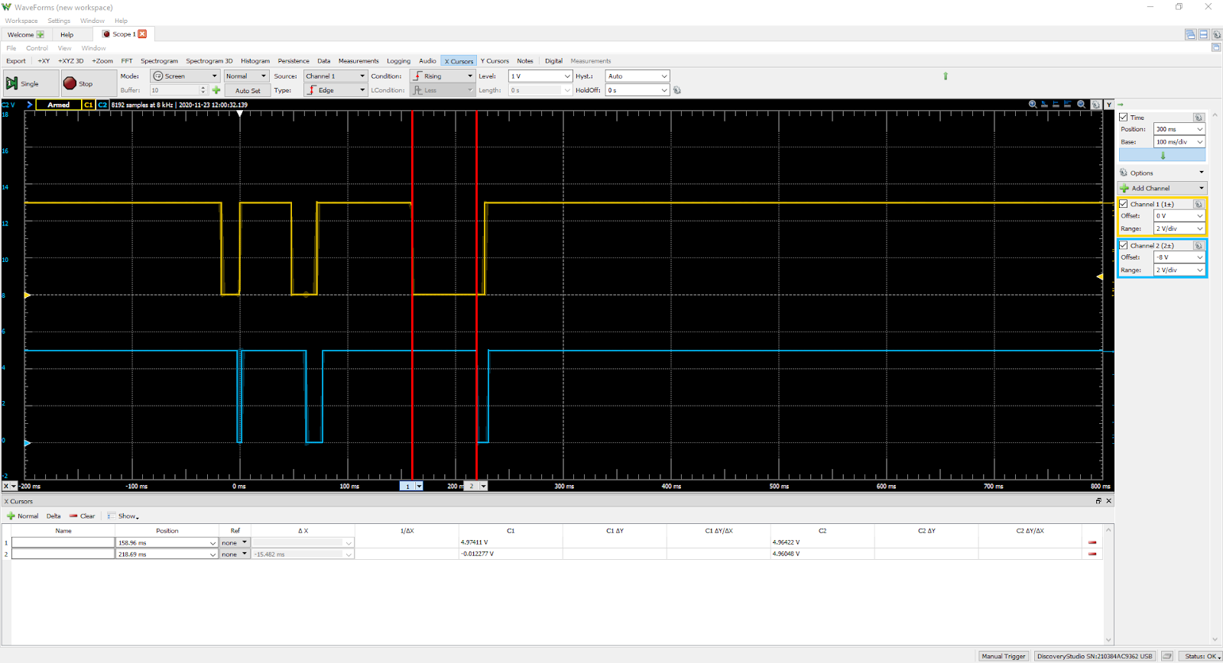

**Fig 16: Medium Rotary Encoder Turns**

**FAST:**

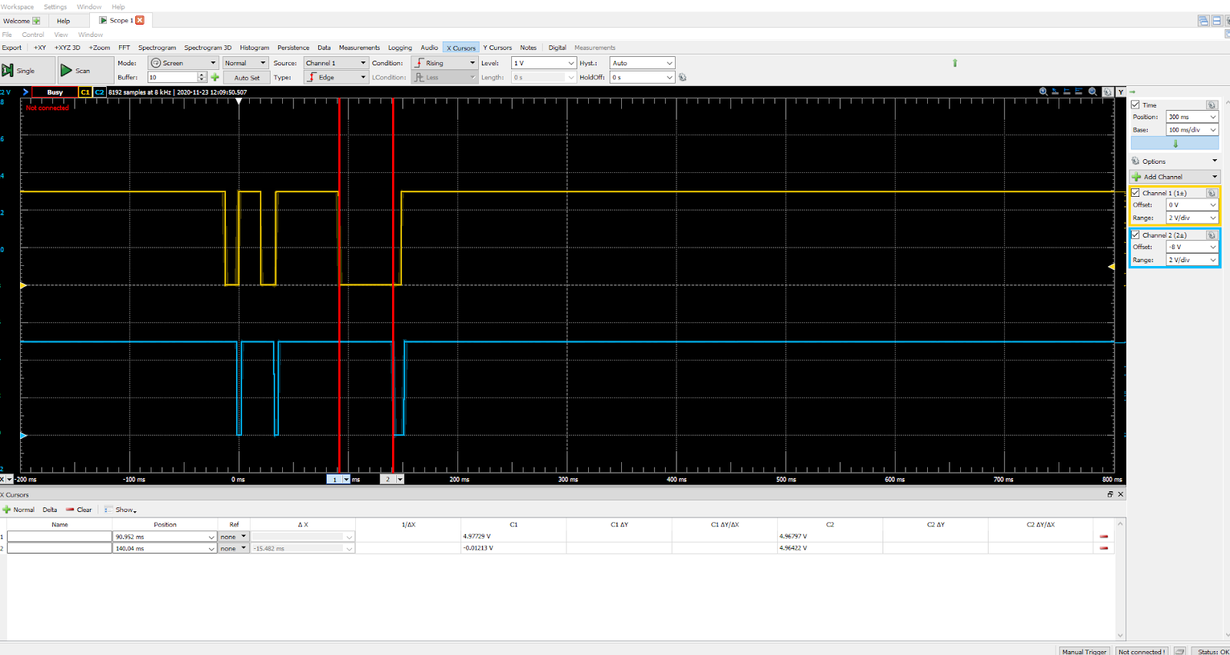

**Fig 17: Fast Rotary Encoder Turns**

**RESULTS:**

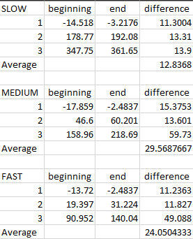

**Fig 18: Rotary Encoder Results**

After doing this experiment, I started writing Verilog code to make the finite state machine that adds and subtracts time.

After a while, I was able to come up with a faster and easier way of reading the rotary encoder. Instead of just guessing when the rising edge of the second signal is going to occur I can just say if the FPGA sees one signal and not the other, then add or subtract one. I still need to keep the ten clock check state because I don’t want to get any false positives. Here is the new finite state machine that I’ll be using.

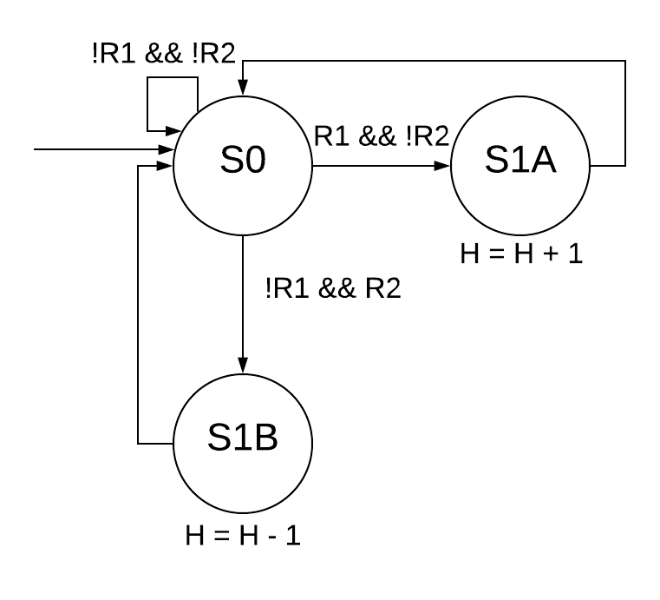

**Fig 18: New HLSM**

**Final Results**

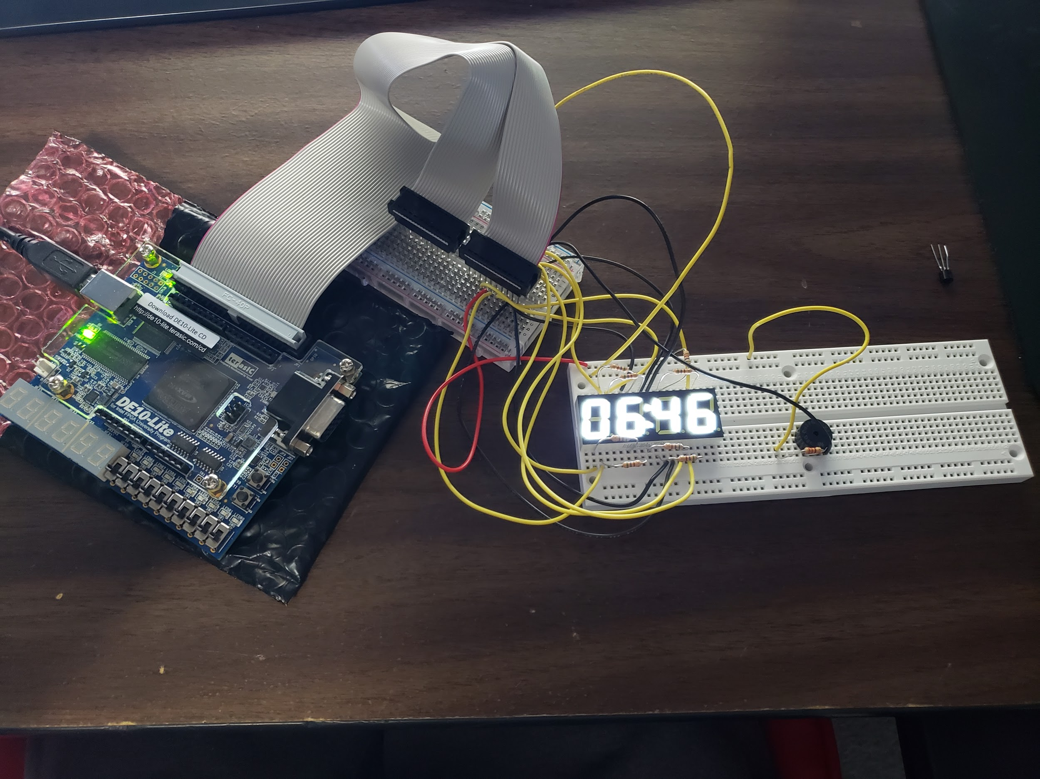

**Figure 20: Completed Wiring and display.**

The final Result can be seen in figure 20. We used the switches and buttons on the FPGA because we ran out of time and could not figure out the rotary encoders. The switches are used to set the time with binary and the buttons are used to switch between changing time mode. SW[9] is used to set the alarm as well as turn it off.

# Manual:

**Set Time:**

In order to set the time, press the KEY0 button to set the device into “Set Time Mode.” If you want to set the hour numbers, leave everything as is. If you want to set the minute numbers, turn switch 8 on. Turn switch 8 off to turn it back to change the hour numbers. To change the one’s place for either of these, turn switches 3 to 0 on and off according to what number you want. The switches are in binary, the 8’s place being switch 3 and 1’s place being switch 0. The same setup goes for the ten’s place, but it’s on switches 7 to 4. In order to set the number that you want, once you have the switches in place, press the KEY1 button. Once you have the time set to what you want, press the KEY0 button to get out of “Set Time Mode.”

**Turn the Alarm on and off:**

To turn the alarm on turn switch 9 on. To turn it off, turn switch 9 off.

**Set Alarm Time:**

In order to set the alarm time, make sure to have the alarm set to on. Press KEY0 to set the device into “Set Alarm Mode.” Once you do this, the display will change and display the set alarm time. The default time is 6:30. In order to change all of the numbers for the alarm time, see the “Set Time” section, the same method used in that section is applied here. Once you have the alarm time set, press the KEY0 button to get out of “Set Time Mode.”

**WARNING:** Do not turn off switch 9 while in “Set Alarm Mode.” When you press KEY0, you won’t be able to get out of “Set Alarm Mode” with the alarm off. If you do turn the alarm off, turn the alarm back on in order to get out of “Set Alarm Mode.”

# Sources:

[1] JoJo, Sun, Liu, “0.56” Quadruple Digit Numeric Displays Technical Data Sheet”, KW4056NXWB-P-Y datasheet, Oct. 23, 2008

[2] *DE10-Lite User Manual*, V1.6 Terasic Inc., Taiwan, Jun. 2016. Accessed on: Nov. 15, 2020. [Online] Available: [DE10-Lite Manual](https://www.terasic.com.tw/cgi-bin/page/archive_download.pl?Language=English&No=1021&FID=a13a2782811152b477e60203d34b1baa)

[3] “PEC11H Series - 11 mm Encoder w/ High Detent Force, PEC11H datasheet, Mar. 2015.

# 

# 

# 

# 

# Appendix:

## Appendix A - Github Tutorial:

Goal: Create a copy of the repository in your personal machine and be able to send and receive updates to the project.

**Terminology:**

Commit: This basically saves the all changes made to your code in the local repository on your machine

Push – Send your updated code to the repository

Pull – Get updated code from the repository

Merge – Take your updated code in one channel and send it to another channel.

**Prerequisites:**

1. Make sure to have Git installed on your machine.

2. Make sure to have Visual Studio Code installed on your machine.

**Step 1:**

Open Command Prompt.

**Step 2:**

Open Windows Explorer and go to where you want to save the version of the code.

**Step 3:**

Go to the top of the tab where it shows the directory and right click on the directory name. Click on the “Copy Address” button.

**Step 4:**

Open a command prompt window and type in “cd <paste directory here>.”

**Step 5:**

Type in “git clone <https address>.” Get the repository https address from the GitHub website.

Address:<https://github.com/davhou23/EENG_220_CLOCK.git>

**Step 6:**

Type in “git config –global user.email dlhout7@gmail.com””. Make sure to include the quotes around the email. Next, type in “git config –global user.name “David Hout””. Make sure to include the quotes around the name.

**Step 6:**

Open Visual Studio Code.

**Step 7:**

Click “File”, click “Open Folder”, and go to where you cloned that project. Click on the project and click “Open Folder”. Now you have access to your own version of the repository.

**Commit Changes:**

There are a few ways you commit changes. First, on the side of the screen there will be a few tabs, one of them is called “Source Control” if you hover over it. Click on it. Now in the text box at the top that says message in it, is where you will put your message (Basically you say what you changed in the code). Then you press the check mark above that to send the commit.

**NOTE**: After you have made changes to the code, make sure to save the code. Otherwise VS won’t see any changes made and won’t commit any code.

**Pull and Push code:**

There are two ways you can do this. First by going down to the bottom left corner of the screen and clicking the up and down arrows. Second, go to the “Source Control” tab. Click the three dots at the top of the tab. There should be two options that say “Push” and “Pull.”

**NOTE:** Make sure you have made committed your code otherwise git will not see any changes that need to be made.

**Merge code:**

When you commit and push code, most of the time you are pushing it to your branch. Now you need to merge your code to the main branch so that your changes are transferred. To do this, you need to go over to the main branch. Go to the “Source Control” tab and then click the three dots at the top of the tab. Click on “Branch”, then “Merge Branch”. Now click on the branch that you want to merge to main.

**NOTE:** While on main make sure to push and pull any changes made to the code before and after you merge branches. Make sure to also update the branch that you are working with the main code so that you are working with the most up to date code. (We’ll probably just end using the main branch and not bother with this).

1. The github instructions are in Appendix A